EXP 20: Implementation of IoT based Smart Agriculture using MATLAB
AIM :
To simulate an IoT-based smart agriculture system using MATLAB by monitoring soil moisture and temperature, and automatically controlling irrigation through pump activation based on sensor readings.

THEORY :
IoT-based smart agriculture integrates sensors, controllers, and automation to improve crop productivity and resource efficiency.
Soil moisture and temperature are key environmental parameters that determine plant health and irrigation needs.
Using IoT logic, irrigation can be automated by continuously monitoring real-time data and activating the pump whenever soil moisture falls below a threshold, ensuring optimal water usage and reduced manual intervention.

PROCEDURE :
- Initialize simulation parameters such as time duration, sensor arrays, pump status, and moisture threshold.
- Generate simulated sensor readings for soil moisture and temperature at each time step.
- Apply IoT control logic to turn the water pump ON when soil moisture is below the defined threshold, otherwise turn it OFF.
- Store sensor values and pump status for each iteration of the loop.
- Display the most recent sensor measurements and pump condition in the command window.
- Plot soil moisture, temperature, and (optionally) pump activity over time for analysis.
PROGRAM :

clear; clc; close all;

%% PARAMETERS
timeSteps = 1:50; % simulation duration
soilMoisture = zeros(size(timeSteps));
temperature = zeros(size(timeSteps));
pumpStatus = strings(size(timeSteps));

moistureThreshold = 40; % below this pump turns ON
pump = 0; % 0 = OFF, 1 = ON

%% SIMULATION LOOP
for t = timeSteps

% 1. Simulated sensor readings
soilMoisture(t) = 30 + 20*rand; % range: 30–50%
temperature(t) = 20 + 10*rand; % range: 20–30 °C

% 2. IoT control logic (Irrigation)
if soilMoisture(t) < moistureThreshold
pump = 1; % turn ON
else
pump = 0; % turn OFF
end

pumpStatus(t) = pump;
end

%% DISPLAY LAST SENSOR VALUES
disp('Latest IoT Sensor Data:');
fprintf('Soil Moisture = %.2f%%\n', soilMoisture(end));
fprintf('Temperature = %.2f°C\n', temperature(end));
fprintf('Pump Status = %s\n', pumpStatus(end));

%% PLOT RESULTS
figure;
subplot(3,1,1);
plot(timeSteps, soilMoisture, 'LineWidth', 2);
ylabel('Soil Moisture (%)');
title('IoT Based Smart Agriculture Simulation');
grid on;

subplot(3,1,2);
plot(timeSteps, temperature, 'LineWidth', 2);
ylabel('Temperature (°C)');
grid on;

OUTPUT :
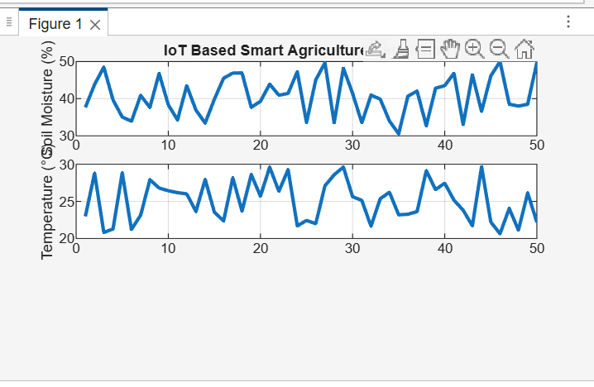

CONSOLE OUTPUT :

Latest IoT Sensor Data:
Soil Moisture = 49.76%
Temperature = 22.20°C
Pump Status = 0
>>

CONCLUSION :
The smart agriculture simulation successfully automates irrigation based on real-time soil moisture data.
The pump activates only when moisture drops below the threshold, ensuring efficient water usage.
This demonstrates how IoT improves agricultural monitoring and reduces human effort through intelligent automation.

